## **Task 1. Retrieve login attempts after a certain date**

In this task, you need to investigate a recent security incident. To do this, you need to gather information about login attempts made after a certain date.

1. Complete the SQL query to retrieve data for login attempts made after '2022-05-09'. Replace X with the correct operator:

SELECT *

FROM log_in_attempts

WHERE login_date X '2022-05-09';

**SELECT * FROM log_in_attempts WHERE login_date > '2022-05-09';**

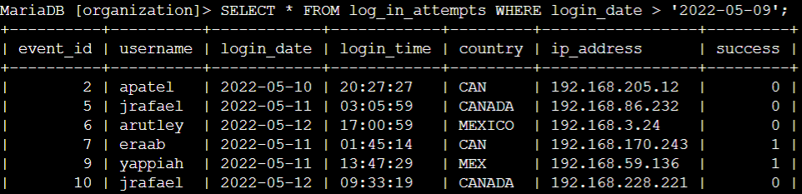

**Now**, based on your first query, you find a need to expand the date range to include 2022-05-09 in your search.

1. Complete the SQL query to retrieve data for login attempts that were made on or after '2022-05-09'. Replace X with the correct operator:

SELECT *

FROM log_in_attempts

WHERE login_date X '2022-05-09';

**SELECT * FROM log_in_attempts WHERE login_date >= '2022-05-09';**

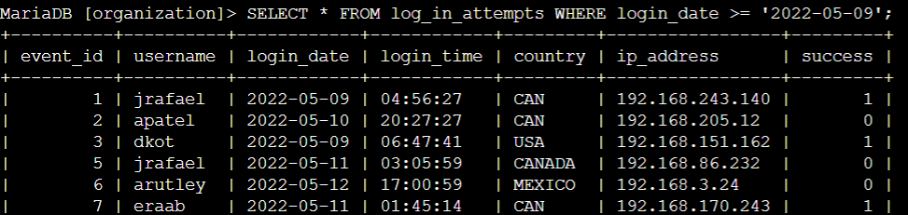

## 

## 

## 

## **Task 2. Retrieve logins in a date range**

In this task, you need to narrow the focus of the search. Login attempts made after 2022-05-11 shouldn't be included. Use the BETWEEN and AND operators to return results between '2022-05-09' and '2022-05-11'.

* Run the query to retrieve the required records. You must insert the required dates X and Y:

SELECT *

FROM log_in_attempts

WHERE login_date BETWEEN 'X' AND 'Y';

**SELECT * FROM log_in_attempts WHERE login_date BETWEEN '2022-05-09' AND '2022-05-11';**

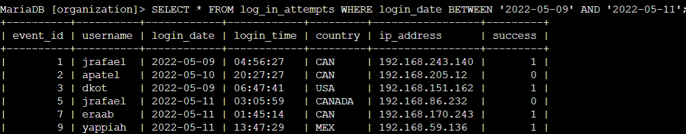

## **Task 3. Investigate logins at certain times**

**In this task, you need to investigate logins that were made at certain times. To do this, filter the data in the log_in_attempts table by login time (login_time).**

**First, your organization's typical work hours begin at 07:00:00. Retrieve all login attempts made before 07:00:00 to learn more about the users who are logging in outside of typical hours.**

1. **Write a SQL query to retrieve data for login attempts made before '07:00:00'**

**SELECT * FROM log_in_attempts WHERE login_time < '07:00:00';**

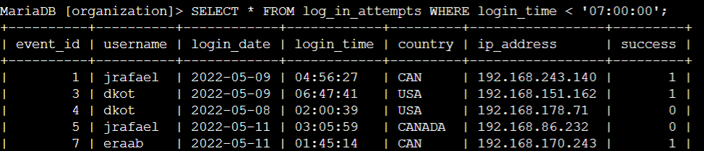

**The query in the previous step returned more results than required.**

1. **Modify the query to return logins between '06:00:00' and '07:00:00'.**

**SELECT * FROM log_in_attempts WHERE login_time BETWEEN '06:00:00' AND '07:00:00';**

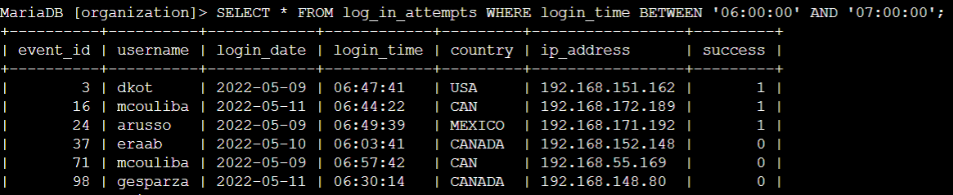

## **Task 4. Investigate logins by event ID**

**In this task, you need to investigate login attempts based on event ID numbers. With this query, you want to return only the event_id, username, and login_date fields from the log_in_attempts table.**

***Note: The event_id column contains numeric data; do not place numeric data in quotation marks.***

1. **Write a query to return login attempts with event_id greater than or equal to 100.**

**SELECT event_id, username, login_date FROM log_in_attempts WHERE event_id >= 100;**

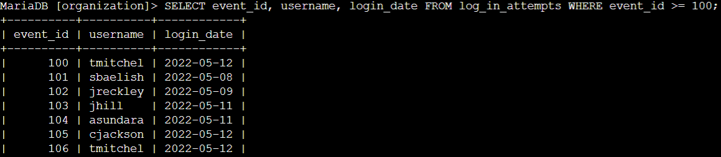

**The query in the previous step returned more data than required.**

1. **Modify the query to return only login attempts with event_id between 100 and 150.**

**SELECT event_id, username, login_date FROM log_in_attempts WHERE event_id BETWEEN 100 AND 150;**

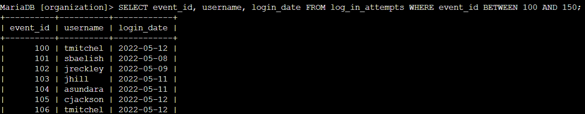

**Conclusion**

**I have completed this activity and practiced applying**

* **the WHERE keyword**
* **the BETWEEN and AND operators, and**
* **operators for working with numeric or date and time data types (for example, =, >, >=)**

**to filter data from a table.**